BIOLOGY
MISS MAZUREK
ROOM 204

Period #9 (with Lab during period #8 M )

August 22, 2019

Dear Student:

Hello and welcome to Freshman Biology. My name is Miss Mazurek and I am a Honors Biology, Biology, and Advanced Placement Biology teacher. Biology is a subject that deals with factual information that will be applied to lab exercises and other activities to develop your inquiry, critical thinking, and analysis skills. The course is divided into four main units that have been designed to cover all of the Biology Standards set forth by the Pennsylvania Department of Education. The four units consist of cell biology, genetics, evolution, and a review of ecology. You will be required to take the Keystone Exam for Biology. This exam will be administered during the month of May. The “passing grade” for the Biology Keystone exam is a score of “proficient” or “advanced”. The modules that you will be tested on consist of the following topics:

Module A: Cells and Cell Processes

Basic Biological Principals
The Chemical Basis for Life
Bioenergetics
Homeostasis and Transport

Module B: Continuity and the Unity of Life

Cell Growth and Reproduction
Genetics
Theory of Evolution
Ecology

You will succeed in this course if you follow the guidelines that are outlined below. I hope you have a FANTASTIC freshman year and wish you good luck during your high school career!!

Miss Mazurek

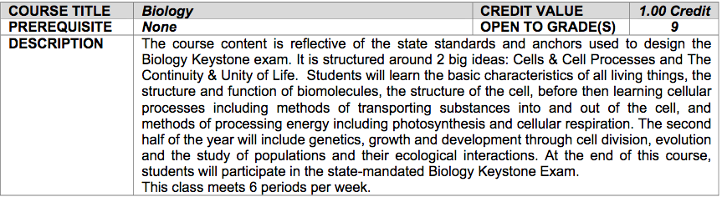

CLASSROOM RULES AND BEHAVIOR EXPECTATIONS:

1. All school policies that are outlined in your student handbook are to be
followed and will be enforced.

2. Be on time for class: You are expected to be in the room and in your seat when the bell
rings.

If you are late, you must have a pass signed by the teacher you were
with. This will be marked as an “excused late with a pass” in Power
School. It does not count against you. You must sign in on the sign-in
sheet (blue) located in the front of my room You will
include the name of the teacher who signed your pass and the time
entered my class.

If you arrive late without a pass, you will be marked tardy. If you
receive three (3) tardies, you will be assigned an after school
detention. My detentions are served in Room 204 from 2:25 – 2:55.
Your parents will be notified.

If you continue to be tardy to my class after your first detention, you
will receive one detention per tardy. I will inform your parents and
administration. Administration may also discipline you.

3. Be prepared for class: You are expected to bring all of your materials to class with you.

pencil/pen
binder with notebook paper
textbook (when required)
iPad (charged and having required apps)

4. First 5 minutes of class: Bell Ringer
You will find this by the Red Crab on my front board.
You will follow the directions and complete the assignment.
It could be pencil/paper or found in Canvas.

5. I do not issue hall passes except in the case of an emergency.

* You must sign out/in when using the restroom pass (green sheet in front of the room)

6. Cell phone use is not permitted during class:

- Please turn them off and place them in your purse or backpack. They will not be out
during class.

** Cell phones will be collected during all exams and reviews of corrected exams.
They will be returned when all students have completed the exam/reviews are done.

*** First offense: I take your phone. You get it back at the end of the period and I call home.

Second offense: I take your phone to the office. Your parents will be notified

7. You will treat everyone with courtesy and respect.

8. Lab Safety Rules: You are required to follow all safety guidelines and rules given during
lab. Failure to do so will result in you receiving a ZERO for the lab. I
do not want anyone to get hurt!!

9. Do not write on the desks or lift them with your legs. Please do not throw your heavy
backpacks on the lab tables (loosens the top) or try to lift the tables free from the bolts
holding them in place.

10. There is no eating or drinking in the room. This includes café purchases. If you have a
medical condition that requires you to have food or beverages, please let me know.

11. My areas (desk, computers, cabinets) are off-limits to you.

12. iPads will be used during class when appropriate. When we are not using them, you will
place it upside down on your desk or keep it in your backpack.

13. Use respectful language at all times.

Elizabeth Forward High School
BRAVE Warriors

Classroom Expectations

- B E SAFE
- Listen to staff
- Maintain personal space
- R ESPECT OTHERS
- Be on time
- Be polite
- Use appropriate language and tone
- A CCOUNTABLE
- Be prepared
- Be honest
- Do your own work
- Use electronic devises only when permitted
- V ICTORIOUS
- Do your best work
- Celebrate academic success
- E NTHUSIASTIC
- Have a positive attitude
- Take ownership of learning

GRADING POLICIES:

- All of your work is graded. These include homework, tests, and labs. Labs and homework make up 50% of your grade and quiz/test scores account for the other 50%. I will give you a grade sheet and show you how to keep track of your scores. I DO NOT CURVE AND I DO NOT ACCEPT LATE WORK!!! I also use the district grading scale and follow the high school grading policy.

90-100 A
80 – 89 B
70 – 79 C
60 - 69 D
0 – 59 F

- If you are absent, you will have that amount of time to make up your work. For example, if you miss three days of school, you will have three days to make up your assignments. Exceptions will be granted for extenuating circumstances. It is YOUR responsibility to see me for your make-up assignments as soon as you return to school. Each class period has 2 folders on the front desk. There are folders for missed assignments and corrected work. Please make sure you look over any work you may have to do before you leave my room in case you have any questions.

- Tests are announced at least one week in advance. For a one-day absence: if you miss the day before an exam, you will take the exam on the scheduled exam day. If you miss the day of the exam, you will take the exam the day you return. I have tutoring for all major exams. Tutoring dates are announced one week in advance too.

- If you decide to skip my class or have an unexcused/illegal absence because you failed to bring in an excuse to your attendance officer within three days of your return to school, you will not receive any credit for that work. This is school policy.

- Extra credit may be earned in three ways. You may turn in a science article from any news source with a brief summary of that article. You will receive 2 points per article (limit 2 per week) and they are due every Friday. I will demonstrate how to do these during class. I always ask three extra credit questions on your exams based on current events. You will have to read the paper, watch the news, and listen to the announcements. I also conduct a review game the day before a test. The rules will be explained in class. The winning team will receive five bonus points.

- Plagiarism or any type of cheating will result in a grade of zero for that assignment.

7. THE GRADE THAT YOU RECEIVE IN THIS COURSE WILL BE THE GRADE THAT YOU
HAVE EARNED!

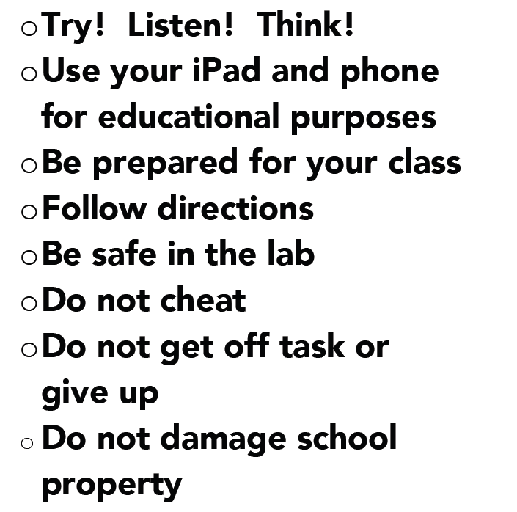

I am here to help you. I cannot help you if you do not ask questions when you are confused. I will do everything I can to ensure your success in my class if you put forth the effort. Giving up or blaming another person for your failure is not acceptable. This class is required to graduate. I am available after school for tutoring as long as you set up an appointment two days in advance because I have various meetings that I am required to attend. This course requires you to STUDY NIGHTLY. Do not try to cram the night before the test. There is too much information to remember and understand. As I previously stated, your grade will reflect your effort.

HELPFUL STUDY HINTS:

1. Place the date on any handouts that you receive along with any notes that you take
in class.

2. Keep a folder/notebook for each class that you have.

3. Review each night. Take your own notes on the material that we covered each day
in class by reading the related sections in your textbook that night.

4. Make your own flashcards for the many vocabulary words that you will have to
learn. You can also use Quizlet or any related app.

5. Ask questions in class.

6. Do not wait until the last minute to study for an exam.

7. Feel free to look up study topics on the Internet. Many sites have quizzes that you
can use to test your knowledge.

8. Do your own homework and take the time to do it correctly the first time. You will
never learn the material if you copy from someone else. When you complete your
own assignments, you can identify your strengths and weaknesses and can ask for
help sooner. If you wait until the night before an exam, I will not be there to
answer your questions.

